import java.util.Scanner;

class account{

Scanner sc=new Scanner(System.in);

String name;

int acct_no;

int balance,deposit;

// String type;

void deposit()

{

System.out.println("Enter amount for deposit\n");

int amount=sc.nextInt();

balance+=amount;

System.out.println("deposite is successfull\n do you want to cheque your balance");

System.out.println("1.YES\n2.NO");

int choice=sc.nextInt();

cheque_balance();

}

void details()

{

System.out.println("Name: "+name);

System.out.println("account_no: "+acct_no);

System.out.println("balance :"+balance);

}

void cheque_balance()

{

System.out.println("Balance is "+balance);

}

}

class savings extends account

{

double intrest=0;

double rate=0.03;

savings(String n,int a,int d)

{

name=n;

acct_no=a;

deposit=d;

balance=deposit;

}

void details()

{

System.out.println("Account_type: Savings");

super.details();

}

void withdrawal()

{

System.out.println("Enter amount for withdrawal\n");

int amount=sc.nextInt();

if(balance<amount)

System.out.println("You can withdraw the amount less than "+balance);

else

{

balance=balance-amount;

System.out.println("withdrawal is successfull..!!!!!!!");

System.out.println("\nDo you want cheque your balance\n");

System.out.println("1.YES\n2.NO");

int choice=sc.nextInt();

if(choice==1)

cheque_balance();

return;

}

}

void get_intrest(int month)

{

month/=3;

intrest=(balance*rate*month/4);

System.out.println("\nPrevious balance: "+balance+"\nIntrest: "+intrest+"\nCurrent balance: "+(balance+intrest));

balance+=intrest;

}

}

class current extends account

{

int cheque_no;

double minBalance=10000;

current(String n,int a,int d)

{

name=n;

acct_no=a;

deposit=d;

balance=deposit;

}

void details()

{

System.out.println("\nAccount_type: Current");

super.details();

}

void serviceCharge(double amount)

{

double charge=0;

System.out.println("Serive charge 6% is applied because of low balance\n");

charge=.08*(minBalance-(balance-amount));

System.out.println("Service charge is:"+charge);

balance-=charge;

return ;

}

void withdrawal()

{

int flag=0;

System.out.println("Do you have cheque");

System.out.println("1.YES\n2.NO");

int choice1=sc.nextInt();

if(choice1==1)

{

flag=1;

System.out.println("enter cheque number");

cheque_no=sc.nextInt();

}

System.out.println("Enter amount for withdrawal\n");

int amount=sc.nextInt();

if(balance<amount)

System.out.println("You can withdraw the amount less than "+balance);

else

{ double scharge=0;

if(balance-amount<minBalance)

{

System.out.println("\nBalance will become less than the minimum balance\nDo you want to proceed\n1.Yes\n2.No");

int newChoice=sc.nextInt();

if(newChoice==2)

{

System.out.println("transaction failed");

return;

}

serviceCharge(amount);

}

balance=balance-amount;

if(flag==1)

{

System.out.println("Cheque Number: "+cheque_no);

}

System.out.println("withdrawal is successfull..!!!!!!!");

System.out.println("Do you want cheque your balance\n");

System.out.println("1.YES\n2.NO");

int choice=sc.nextInt();

if(choice==1)

cheque_balance();

return;

}

}

}

class Main

{

public static void main(String[] args)

{

Scanner sc=new Scanner(System.in);

String name;

int acct_no;

int deposit;

int choice;

System.out.println("Enter your name\n");

name=sc.nextLine();

System.out.println("Type of account\n");

System.out.println("1.current\n2.Savings");

choice=sc.nextInt();

if(choice==2)

{

System.out.println("Enter amount for deposition and minimum ampunt 1000 rupees\n");

deposit=sc.nextInt();

System.out.println("Create account number \n");

acct_no=sc.nextInt();

savings s=new savings(name,acct_no,deposit);

while(true)

{

System.out.println("\nEnter your choice\n1.deposite\n2.withdrawal\n3.Details of account\n4.intrest Calculate\n5.exit\n");

int ch=sc.nextInt();

if(ch==1)

s.deposit();

else if(ch==2)

{

s.withdrawal();

}else if(ch==3)

{

s.details();

}

else if(ch==4)

{

int m;

System.out.println("Enter duration for intrest calculate\n");

m=sc.nextInt();

s.get_intrest(m);

}

else if(ch==5)

break;

else

{

System.out.println("Invalid Choice..!!!!!\n");

}

}

}

else if(choice==1)

{

System.out.println("Enter amount for deposition\n");

deposit=sc.nextInt();

System.out.println("Create account number \n");

acct_no=sc.nextInt();

current c=new current(name,acct_no,deposit);

while(true)

{

System.out.println("\nEnter your choice\n1.deposite\n2.withdrawal\n3.Details of account\n4.exit");

int ch=sc.nextInt();

if(ch==1)

c.deposit();

else if(ch==2)

{

c.withdrawal();

}else if(ch==3)

{

c.details();

}

else if(ch==4)

break;

else

{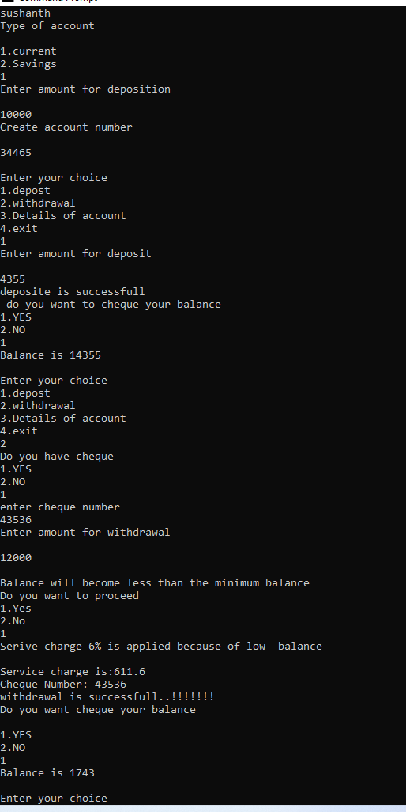

System.out.println("Invalid Choice..!!!!!\n");

}

}

}

}

}

